The table displays the change of how many household appliances people in Britain owned during 1972 to 1983.

Overall, the proportion of all durables saw a upward trend in the given period. The ownship of television maintained the highest throughout the period, while the telephone owner rose the most.

93% British people owned television in 1972, and this figure increased slightly till 1983, almost all family in Britain possessed television. The proportion of vacuum cleaner and refrigerator noticed a similar trend, from 87% and 73% in 1972 rose to 95% and 94% respectively at the end of the period. The figure of washing machine also increased about 15% during the 11 years.

The proportion of telephone owner soared about 35%, from 42% to 77%. Central heating accouted for the lowest at the beginning, just lower than 40%, but it rose by over 20% and became 64% in 1983. It is worth noticing that there was no vedio and dish waher in 1972, they were invented during the period and accounted for 18% and 5% respectively in 1983.

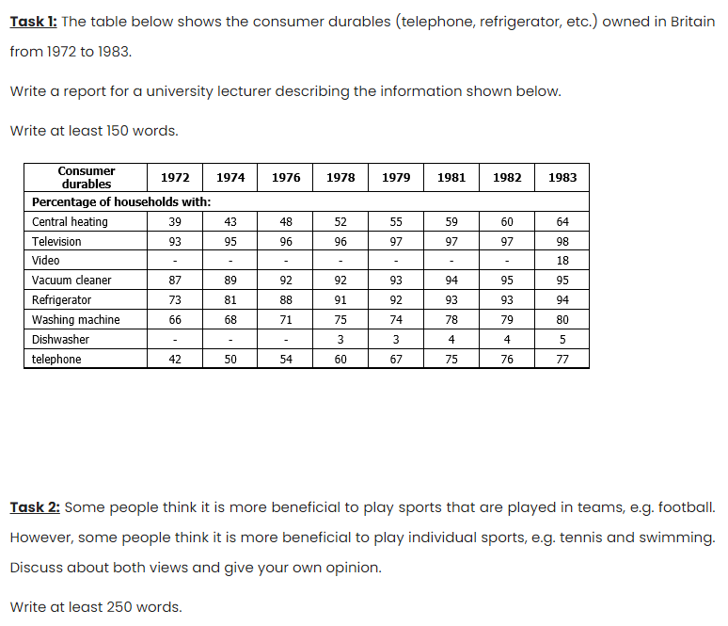

Some argued that engaging in team sports is better as it is beneficial to our communication skills, while others believe that playing sports individually is optimal because it allows us to perform better. From my perspective, I agree that we should do sports in a team as soft skills is pivotal in our life.

On the one hand, some people opine that participating in team sports improves people’s social skills. That is because, when people engage in sports like football or basketball, they must cooperate with their teammates. In which case, they are allowed to learn how to verbalize their feelings in a more appropriate way, and communicate with their peers to strive for the final victory together.

Additionally,

But in contrast to that, some argue that doing individual sport propels people to perform better. Unlike playing team sports with peers, doing sports individually means both coach and athlete can focus much more on the athlete himself rather than keeping an eye on others. In other words, he can enjoy more resources than working in a team, and his pros can be maximized. As a result, he is more likely to gain a better outcome and become more confident than working with others.

In conclusion, although playing individual sports may invigorate athlete’s performance, I believe team sports is worth joining because better soft skills help us integrate into the society.